Split-Flap Display Wall: Project Proposal

Executive summary
We request $900 to build a 45-character split-flap display wall: 3 rows × 15 columns of mechanical flaps, with a voice-controlled assistant. The listed parts total $856. Shipping from the remaining vendors brings the realistic all-in cost to $890–920.
The money buys the parts listed below. Every one of them is needed for the wall to work:
- 45 motorised flap modules on custom circuit boards
- the rail and bus that power and connect the modules
- a Wi-Fi controller and a 12 V power supply
- an LED light strip around the edge
- a Raspberry Pi with a far-field microphone for "Hey Venus" voice control
The budget is already cut to the minimum:
- Parts we already own are listed at $0. These include the wire, connectors, resistors, buck converter, capacitors, microSD card and speaker.
- The circuit boards use the cheapest assembly tier.
- The motors are bought direct from the factory at $1 each.
- Every printed part (enclosures, drums, gears, 2,880 flaps and the cases) is printed in-house at no charge.

Goals and scope
The goal is a working wall that shows text, time, weather and voice-assistant answers on real mechanical flaps.
Goal | How we'll know it's met
45 cells showing any character on the reel | Every cell lands on the right flap after a HELLO test and a full-alphabet test
Snap-on modules with no wiring between them | Any module can be pulled off and clipped back without tools
Network control | Text sent from Home Assistant and the Companion app appears on the wall
Voice control | "Hey Venus, what's the weather?" puts the answer on the flaps from 5 m away in a noisy room
LED status ring | The perimeter strip glows while listening, circles while thinking, and pulses while answering
Split of work. Kevin owns the hardware and gateway: the modules, RS-485 bus, ESP32 gateway firmware and LED strip. Jace owns the Raspberry Pi software: Home Assistant, the voice satellite, the LLM and the Companion app. A written interface contract fixes how the two sides talk. A mock gateway already lets Jace build and test the software side without any hardware.

How a split-flap module works
Each cell is a self-contained module. A stepper motor turns a drum of 64 flaps, and a magnet and Hall sensor tell the module where "home" is. Each module is about 78 × 80 × 37 mm.
What one module contains:
- Microcontroller: an ATtiny1616 at 3.3 V logic, running the module firmware.
- Motor: a 28BYJ-48 stepper turns the flap drum. A ULN2003 driver runs it from a separate 12 V motor supply, not the logic rail.
- Home sensing: an A3144 Hall-effect sensor detects a 3 × 1 mm N52 magnet on the drum to find the home position.
- Communication: a half-duplex RS-485 transceiver, with its driver-enable line on a GPIO.
- Connection: a DIN-rail clip and four pogo pins on the underside. These are the module's only electrical connection.
- Flaps: 64 per drum, covering letters, digits, punctuation and seven solid colours: red, orange, yellow, green, blue, purple and white. Flap 0 is the blank "home" flap.
Flap budget. A drum holds at most 64 flaps. The blank, A–Z, 0–9 and the seven colours use 44, leaving 20 for punctuation. A character not on the drum makes the module go home and leave the cell blank. To prevent that, the software replaces unsupported characters before sending; for example, Å becomes A.
Homing and calibration. One full drum turn is about 4,096 motor steps. On power-up, each module spins until the Hall sensor sees the magnet, then moves a stored home offset (default 2,832 steps) to center the blank flap. Each flap position is worked out as (index × total steps) ÷ 64.
Three values are calibrated once per module from the gateway dashboard and kept in its EEPROM:
- the measured total steps per turn
- the home offset
- optional tweaks for individual flaps
This is why every module needs a magnet and a sensor: without them the drum has no reference point and drifts.

System architecture
The system has four paths: voice, control, display and power.
- Voice: the Raspberry Pi on the floor listens for "Hey Venus" and works out the answer.
- Control: the Pi sends the answer over Wi-Fi to the ESP32 gateway.
- Display: the gateway drives all 45 modules over one shared RS-485 bus built into the DIN rails.
- Power: one 12 V supply feeds the rails and the LED strip.
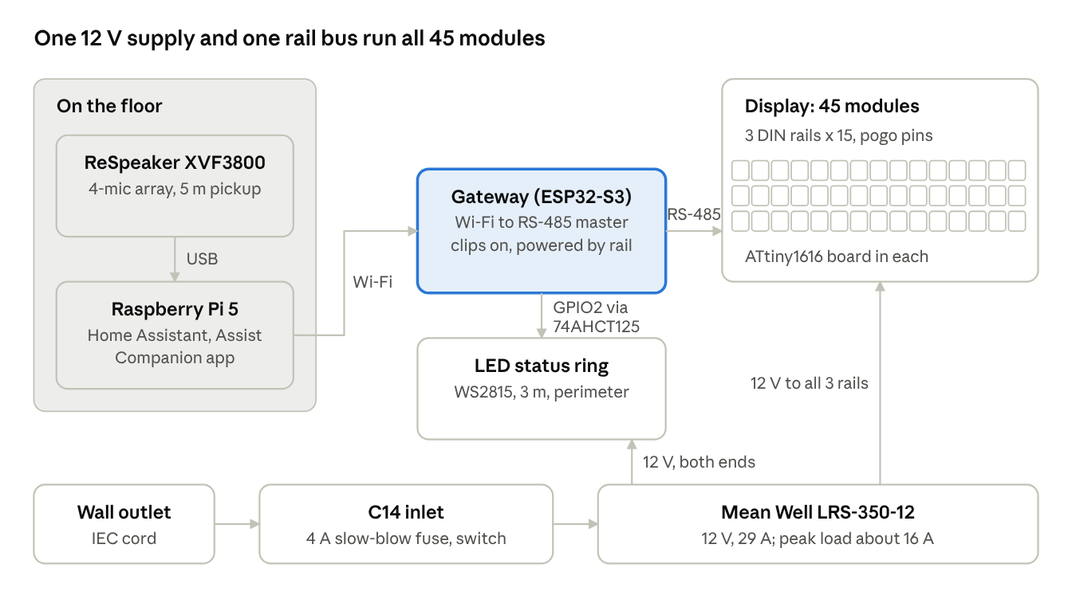
system architecture · voice, control, display and power paths
All display text from the Pi goes through the Companion app. The Pi talks to the gateway directly only to set the LED state. Every answer is filtered down to characters that exist on the flaps before it is sent.

Hardware design
The project has eight hardware subsystems. Six reuse proven open designs. Two are our own: the driver PCB revision and the LED status ring.

1. Module mechanics
Each module has 11 printed parts plus 64 flaps:
- enclosure body and two covers
- drum body and drum cap
- DIN-rail mount
- motor gear, centre gear and gear plate
- wire retainer
Across 45 modules that is 2,880 flaps. Each module also takes:
- 12 M3 nuts
- four M3 × 8, four M3 × 30 and four M3 × 40 countersunk screws
- one 12 V 28BYJ-48 stepper
- one A3144 Hall sensor on a JST-PH 3-pin lead
- one magnet
- four 9 mm gold pogo pins

2. Driver PCB (Kevin's design)
Every module carries one driver board of Kevin's own design: a 30 × 60 mm, 2-layer, 1.6 mm PCB. It takes the four rail lines from the pogo pins and runs that cell's motor, home sensor and bus link.
Power path. 12 V enters on a pogo pad and passes a 0 Ω link onto a filtered 12 V rail. A 100 µF bulk capacitor and 470 nF, 10 µF and 100 nF ceramics on that rail absorb the motor's current spikes. The filtered rail feeds three loads:
- the stepper motor directly, as the common supply on its plug
- a 5 V SPX3819 regulator, which powers the Hall sensor
- a 3.3 V SPX3819 regulator, fed from the 5 V rail, which powers the microcontroller and the RS-485 transceiver
Running the two regulators in series splits the voltage drop between them, so neither runs hot.
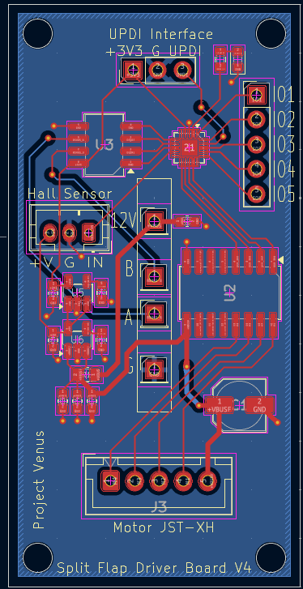
Signals.
- Four ATtiny1616 pins drive the ULN2003's inputs. Its outputs sink the four motor coils on the JST-XH plug, and its clamp diodes return coil flyback to the 12 V rail. The three spare ULN2003 channels are unused.
- The Hall sensor's output goes straight to one ATtiny pin.
- The SN65HVD72 transceiver connects to the ATtiny's UART TX and RX lines. Its driver-enable and receiver-enable pins are tied to one GPIO, so the module drives the shared bus only while it is replying.
- A status LED on one pin shows the module's state.
- The 3-pin UPDI header (3.3 V, GND, UPDI) is the programming port.
- Five spare GPIOs are routed to the optional J5 header for future add-ons.
Ref | Part | Package | Job
U1 | ATtiny1616 | VQFN-20, 3 × 3 mm | Runs the module firmware and stores calibration in EEPROM
U2 | ULN2003 | SOIC-16 | Drives the 4 stepper coils from 12 V
U3 | SN65HVD72 | SOIC-8 | 3.3 V RS-485 transceiver to the shared bus
U6 | SPX3819, 5 V | SOT-23-5 | 12 V → 5 V for the Hall sensor
U5 | SPX3819, 3.3 V | SOT-23-5 | 5 V → 3.3 V for the logic
C1 | 100 µF electrolytic | 5 × 5.4 mm | Bulk storage on the 12 V rail
C2–C9 | 470 nF, 10 µF, 100 nF | 0603 | Decoupling and regulator bypass
R1 | 0 Ω link | 0805 | Joins the incoming 12 V to the filtered rail
R2, D1 | 51 Ω + red LED | 0603 | Status light
J1 | 1×3 header | 2.54 mm | UPDI programming port
J3 | JST-XH 5-pin | 2.5 mm | Stepper motor plug
J4 | JST-PH 3-pin | 2.0 mm | Hall sensor plug (5 V, GND, signal)
J5 | 1×5 header | 2.54 mm | Spare IO, not fitted
J2, J6–J8 | Pogo-pin pads | – | 12 V, GND, A, B from the rail
Assembly and cost. JLCPCB machine-assembles 50 boards (45 plus 5 spares) on its Economic PCBA tier. Each board has about 79 surface-mount joints and 11 through-hole joints. Every part is 0603 or larger, which keeps the board on that tier. The parts cost about $2.40 per board. Fully assembled, with setup, tariff and shipping, each board comes to about $5.90. The four pogo pins are soldered to their pads by hand during module assembly.

3. Rail and bus boards
No wire runs between modules. Each row is a 35 mm steel DIN rail carrying a conductor bus board with four tracks: 12 V, GND, RS-485 A and RS-485 B. A module snaps on, and its pogo pins touch the four tracks.
- The 5-module bus board is 202 × 24 mm; three cover a row, so the wall uses 9, plus a spare.
- The rows link with a short twisted pair for A/B and 18 AWG wire for power.
- The bus runs at 9600 baud, 8N1, and supports up to 255 modules.
- A 120 Ω resistor terminates the far end.

4. Gateway
A Waveshare ESP32-S3-RS485-CAN board ($18.99) is the bus master and the wall's network interface. It has an on-board RS-485 transceiver, 2.4 GHz Wi-Fi, a REST API and optional MQTT.
The board comes out of its stock box and goes into a printed case that clips onto the same DIN rail. Four pogo pins glued into the case take 12 V, GND, A and B straight from the rail, so the gateway needs no separate supply or bus wiring. Assembly steps:
- Shorten the three indicator LEDs.
- Solder short wires from the pogo pins to the pads beside the screw terminals.
- Check every pin with a meter before first power.
The 12 V wire has to go to the right pad: get it wrong and the board is destroyed.
All 45 modules run the same firmware. The gateway gives each one its ID (0–44, row × 15 + column) at runtime, and also runs calibration and diagnostics.

5. Programming
Modules are flashed on the bench before mounting, through a SerialUPDI programmer. It is a CH340 USB-serial adapter with one 1N5817 Schottky diode soldered on, and it powers the module while flashing. It takes about ten minutes to build and costs about $16 in parts.

6. Power
A single Mean Well LRS-350-12 supplies 12 V at up to 29 A for everything.
Load | Peak current at 12 V
45 steppers | about 7 A
LED strip at full white | 6–8 A, much less at the capped brightness
Gateway | under 1 A
Total | about 16 A, leaving 45% headroom
Mains enters through a black C14 inlet with a fuse drawer and a rocker switch. The drawer takes a 4 A slow-blow 5×20 mm fuse. Inlet-to-PSU wiring is mains-rated three-wire cord, with earth bonded to the PSU frame. The 12 V runs to the three rows and both strip ends use 18 AWG wire and WAGO 221 lever connectors.

7. LED status ring
A 3 m WS2815 12 V strip at 144 LEDs/m lines the roughly 1.7 m perimeter. The extra length allows for mounting and spares. It shows the voice assistant's state: listening, thinking or speaking.
- Data comes from gateway GPIO2 through an SN74AHCT125 3.3 V → 5 V level shifter. That shifter runs from a small buck converter we already own. A 330 Ω resistor sits at the strip.
- The strip is powered directly from the PSU, injected at both ends, with a 1000 µF capacitor at the input. It never draws power through the gateway or the module rail.

8. Voice side (Raspberry Pi)
The voice side runs on a Raspberry Pi 5 (4 GB) with the official 27 W supply and Active Cooler. It runs Home Assistant, the Assist voice satellite, the Companion app, and whisper. We want to be able to do Speech to text locally and have determined through reddit and LLM asking that 2GB is not enough ram to do this reliably, so we are requesting the 4GB version.
For the microphone, a Seeed ReSpeaker XVF3800 USB 4-mic array gives 360° far-field pickup rated to 5 m. It has beamforming, noise suppression and echo cancellation. A cheap USB mic would not be able to pick up speech from different areas. We would have to talk to it right up close.

Budget
The parts list totals $856: $637.66 for the wall and $218.53 for the Pi and voice side. The figures already include JLCPCB's and Elecrow's shipping and tariffs.
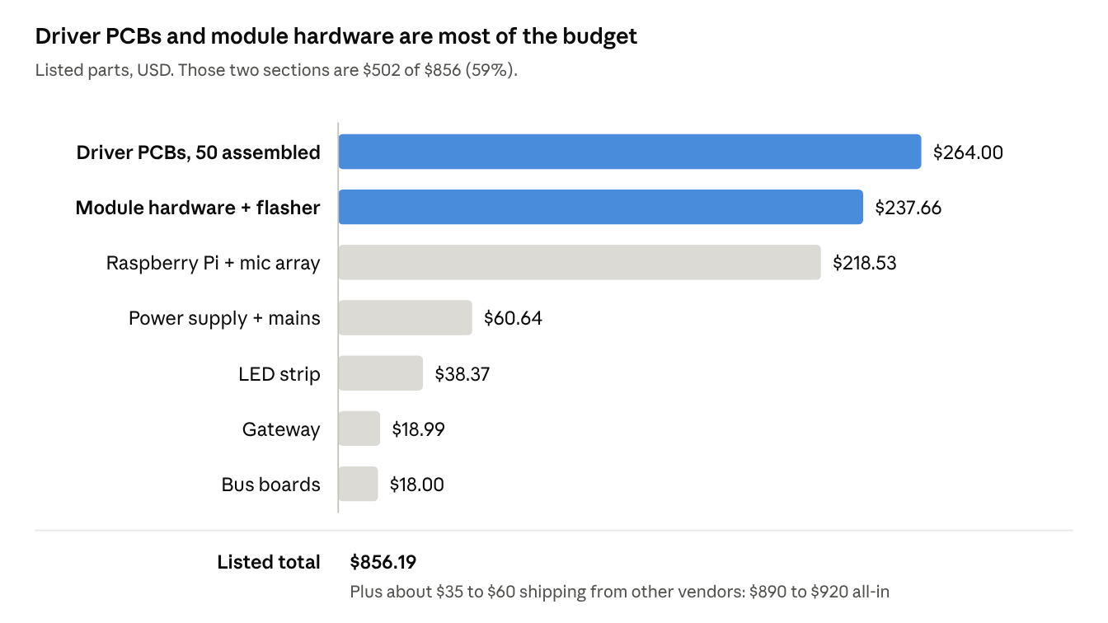
budget by section · prices as of Oct 2026
Remaining shipping from Vetco, Adafruit, Seeed, Bravo Electro and Waveshare adds $35–60; Amazon orders ship free. That puts the realistic cost at $890–920.

Why each dollar is needed
Every line in the budget is a part the wall cannot run without, bought in the smallest pack that covers 45 modules.
Item | Cost | Why it's needed
50 assembled driver PCBs | ≈ $264 | One controller board per module plus 5 spares; the 3 mm VQFN chip needs machine assembly
Stepper motors (50) | $75 incl. shipping | One per module, bought direct from the factory at $1 each
Pogo pins (184) | $25.98 | The only electrical link from each module and the gateway to the rail
N52 magnets | $21.59 | The home reference for every drum; a strong magnet gives reliable homing
Mean Well LRS-350-12 | $33.30 | Powers the 16 A peak load with headroom and built-in protection
ReSpeaker XVF3800 mic | $60.99 | Hears "Hey Venus" at 5 m in a noisy room
Raspberry Pi 5 4 GB + PSU + cooler | $157.54 | Runs Home Assistant, voice and the Companion app
Waveshare gateway | $18.99 | Wi-Fi to RS-485 bus master; clips onto the rail
LED strip + level shifter | $38.37 | Shows listening, thinking and speaking around the perimeter
Screws, nuts, sensors, cables, rail, UPDI flasher | $115.09 | Mechanical assembly of 45 modules, plus flashing their firmware
Already owned, $0 to the board: jumper wires, resistors, twisted pair, 18 AWG wire, mains cord offcut, WAGO connectors, heat-shrink, buck converter, capacitors, perfboard, microSD card and speaker. Every printed part (about 500 parts plus 2,880 flaps) is printed in-house.

THE FULL BOM CAN BE FOUND HERE https://github.com/wangykev/Splitflap/blob/main/Kevin%20Splitflap/BOM.md

